How to post calendar events on pros
- Log in as administrator
- Go to the event calendar link
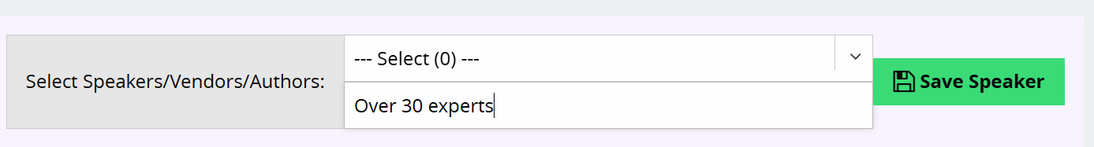
- Start with “Manage speakers” link on the drop down. Open the tab and enter “Over 30 experts”, then hit the “save speaker” button

- Go back to Event Calendar. Open the Manage Events Locations tab. Scroll down to Manage Location box, type in “Great Wolf Lodge, Mason (Cincinnati) Ohio. Ignore the address and so on; they will get that when they click the link in the event writeup. Click SAVE LOCATION.

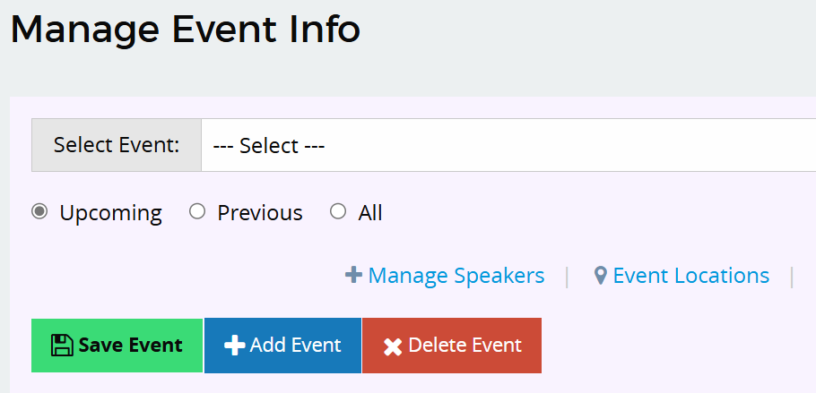
- Go back to the Even Calendar tab and Click “Add Event”

- For Event Type, Choose “Workshop/Seminar 2+ Days”

- For Location, select Great Wolf Lodge, Mason (Cincinnati) Ohio

- For Speaker type “Over 30 Experts” in the search box.

- For the event schedule—THIS IS A LITTLE WONKY, so read carefully.

- FIRST, put in October 31st in the date box, 8;30 AM in the start time box, and 9:00 pm in the end time box.
- THEN change # of events to 4, and frequency to daily
- THEN change the end time of the 4th event to 5:30.

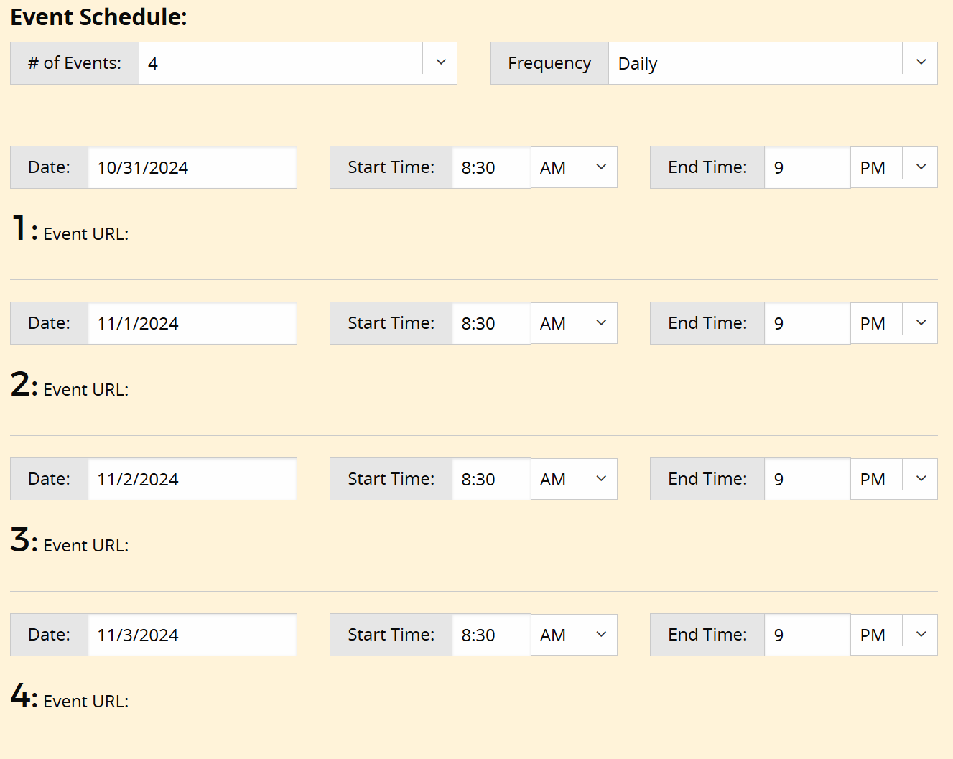

- Scroll down to Event Page Content, and cut and paste the event page content from the marketing into this box.

The formatting will disappear when you do this, so if you want it to look like the way it’s formatted, you’ll have to do that through pros.

- THIS IS VERY VERY IMPORTANT: scroll down to the event pricing tab, open it, and scroll down to where it says registration button. Click the disable registration button box. If you don’t do this, people will register through YOUR website, and they won’t have a ticket when they get there!
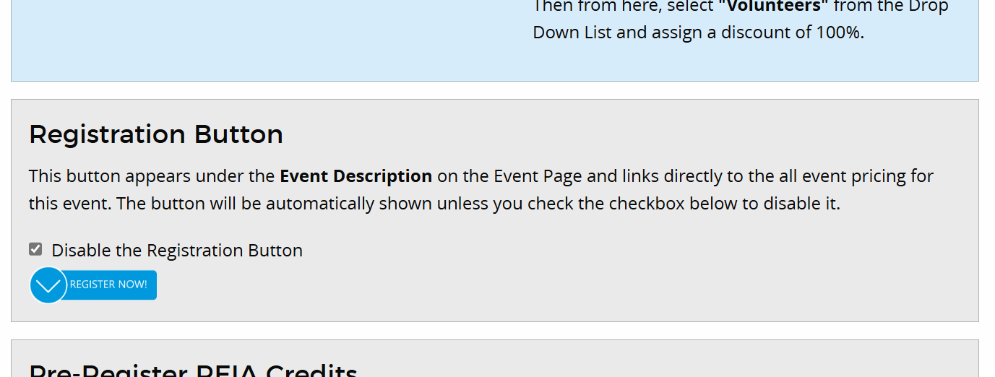

- Don’t forget to save the event. And feel free to click the “Featured Events” box at the top of the page!

- Before you decide you’re done, open a new tab in your browser, go to the calendar even NOT as an admin, click on it, and look to make sure it’s what you wanted (and that the registration links are live!)

